Project Erasmus + Cooperation for innovation and exchange of good practice

KA229 - School Exchange Partnerships

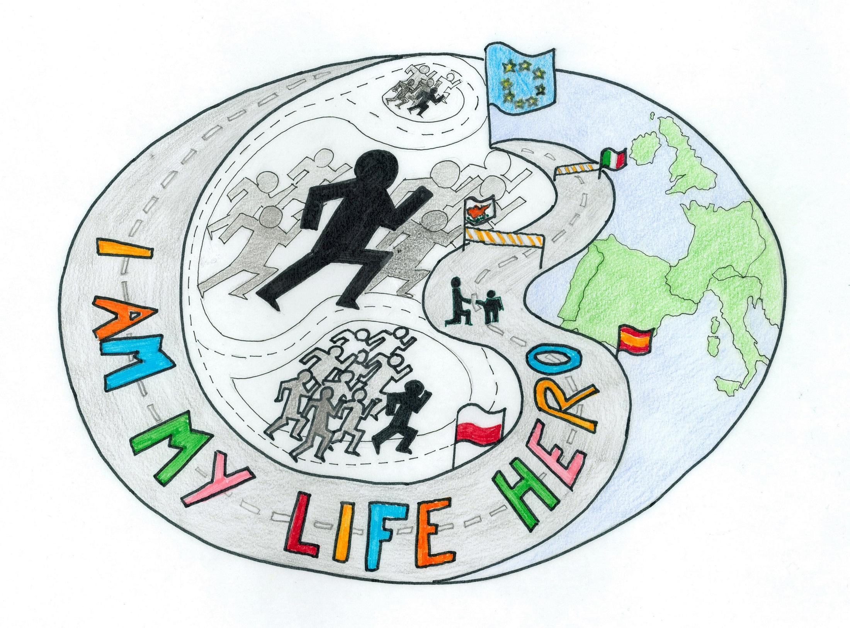The project title: I am my life hero
Students' age: up to 15
Time: September 2018- August 2020
Partners: Poland, Cyprus, Spain, Italy

no | Event | Mobilities  Teachers/Students | Country | Date
1 | National Hero Week | no | all | November 2018
2 | Health Hero Week | 2/3+5/6 | Cyprus | March 2019
3 | Sport Hero Week | 2/3+5/6 | Italy | May 2019
4 | Team Hero | 2/3+5/6 | Spain | February 2020
5 | Final SMART hero Week  - to sum up the project | 2/3+5/6 | Poland | May 2020

Date | Ist year 2018/2019  Activity- subjects and tasks | Participants | Methods
September 2018 | The start of the project-Logo and aims of Erasmus+  presentation of the project- project's aims, countries, map+distances  The start of the eTwinning project  - to choose the school logo- sts make A3 posters to present the project theme  - to work over the word HERO- to describe a hero in adjectives  - to prepare a common survey and do it in the schools and communites,  The survey about Hero in my life: Have I met any?/ Have I got one?/ Have I ever been?  - to sum up the survey according to the age: the olds /adults/ the young/ children and present it in powerpoints  - to invite and inform the kindergartens and the minorities about planned events | School coordinatorsAll students  10-15 year- olds  12-year-olds  12-year-olds  11-year-olds | Art and craft  brain storming  ICT
October | Who is Hero:  - to make presentations of the schools and countries and inform the communities about the project  - to present surveys about Hero  - to show presentations of the project and schools on the local level | All students  12-15year-olds | brain storming, mind maps
November | 1st Week- National Hero – the school event  - to present the hero (whom I admire) of history/ sport/ -poems/ stories/ powerpoints/ art works/  - the leaflet about heros, national holidays concerning the history  - a vote for my hero on the website  - to visit the place concernig the country hero  - to celebrate the hero day at school with the presence of the minorities (kindergartens/the blinds/the olds/the handicaped) | all partners  the whole community  minorities  teachers  parents | Art & craft  TIK  Vote for  historical  visit

January 2019 December | Hero around us- Hero of my relatives  - to present good habits- discussion with parents and others, choosing the person  - TV spot- a film about my hero  - competitions about family hero- posters/photos  - presentation of the work at parents' meetings | Families  kindergartens  13-15-year-olds  all students  teachers | Discussion  TIK  art
February | I've got the power - How to fight for oneself  - interviews, meetings with the blind/ the handicapped/ the minorities  - meetings with psychologists , the blind/ handicaped inspiring students – education of motivation- my good features  - to prepare drama presentation- role - play  - create workshops of talents | Parents  kindergartens  the minorities | Trip  drama  Art  ICT
March | 1st meeting - Healthy Hero in Cyprus  - to organise workshops about healthy food & cooking  -workshops to cook different recipes with healthy ingredients; alternative healthy cooking vs traditional cooking.  - to write the Decalogue of healthy life- posters  - construct a food pyramid embodying the Mediterranean nutrition.  - design healthy meals according to «My Plate» guidelines.  - workshops informing students of all the negatives related to smoking, alcohol, drug and internet addiction.  - healthy day " Skip for the heart"  - meetings for parents- How to grow up a hero  - present the visit meeting in the local newspaper/ website  - page of the project diary- memories after the visit | Partners  all  students  groups  parents | Event  1st trip  art  craft  ICT  workshop
April | Hero of active life  - to present the 1st visit meeting in the local newspaper/ website  - to prepare the next visit- Sports Hero  - interviews with sportsmen (old,handicapped,young)-  powerpoints, photos, posters | School community  kindergartens  teachers | Workshops  ICT
May | 2nd meeting Sport Hero Week in Italy  -to organise sports family event- short walks, jogging, school competitions  - to present local sports people  - page of the project diary- memories after the visit | Partners coordinators | Event  2nd trip  ICT
June | - Hero Kid- I've got the talent- talent show  - exchibition of the project works in front of the school  and presentation in the local website/ newspaper  - What's the most important in my everyday life?  - to continue the blog- 6th page | 12-year- olds  teachers | Events  ICT
July-August 2019 | Holiday competitions:  - Photos & short films of heroes  - Heroes of the literature- the description of a favourite character  - to create quiz Googlemaps  - preparation for the project 2nd year | Students  9-12-year-olds  teachers | Art  writings  ICT

Date | 2nd year 2019/2020  Activity- subjects and tasks | Participants | Methods
September | - presentation of holiday competitions  - presentation of emaps  - the start of eTwinning+ 2nd year | Schools  kinderkartens  all | Show  meetings
October | Small and big hands give help  - to present the work of local service- policeman, firefighter, doctor - interviews  - to practice first aid help- how to help in everyday accidents - presentations/films  - to present local authorities- meetings, interviews  - to visit places of local workshop- meeting interesting people | 11-12-year-olds  local people | Workshops  meetings
November December | I fight my weak points- I work on my good points  - to promote good styles of families- active, healthy  - to show healthy recipes of local meals- book of recipes  - to present ways of preparing food | All schools  kindergartens  invited groups | Cooking event  Art
Februarz January2018 | Our talents  - school workshops- the choice of future job- presentation of professions  - to exchange talents- meetings with parents, grandparents, others to share | 12-15-year-olds | Meetings  event  interviews
March | ^{3rd} visit Team Hero in Spain  - workshop about human towers and benefits of team  - Kahoot and other apps for teamwork  - meeting with an expert who works cooperatively.  - visit buildings built cooperatively in Barcelona.  - families introduce jobs where they work in team  - visit local radio and visit places where minorities work recycling collaboratively  - page of the project diary- memories after the visit | Partners  12-year-olds | 3rd Trip  visit
April | - to present the 3rd visit meeting in the school/ local newspaper/ website  - Technology Week  - workshops - invite the minorities into Ozobots- programming, coding  - to prepare the next visit- modern technology in education | Local community  up to 15-year-olds | ICT  Art  Craft
May | ^{4th} visit Final Week Smart Hero  - to sum up the project at the Hero Festival + hero prizes  - to present & exchange the calendars of all project works and songs I am the hero  - to present the project eTwinning/ blog  - page of the project diary- memories after the visit | Partners  School community  local authorities | Event  Art  book  ICT  music
June | Presentation of the project at the school community & on the school website  - the project book and diary- e-book & printed | All schools | Meetin  presentation  ICT
July | Presentation of the project in the town &  the town website | All partners
August | Presentation of the project in the country  final page of the project blog  - on the eTwinning site, Erasmus+ | Poland
Final products of the project:
1. school:
- events- meetings, workshops, competitions, discussions, interviews, websites, diary pages of the visits
- emap Google
- diary after the events- ebook, printed
- the project calendar
- the project song I am the hero
- Tutorial National Hero
- Healthy Hero guide

2. local – leaflets, newspaper, websites

3. European- school websites, FBeTwinning project

